ANSWER SHEET
SOLUTIONS 2013 Chemistry 3AB Semester 2
Section One (50 marks)
Year 12 CHEMISTRY 3A/3B 2013 Multichoice.
Name___________________Teacher_______________
For each question, shade the box to indicate your answer.
Use only a blue or black pen. ◻ ◻  ◻
If you make a mistake, please place a cross through that square, do not erase or use correction fluid. Shade your new answer.
In the event that you then change your mind back to your original answer, you then cross out the second selection and then circle the first choice.
No marks will be given if more than one answer is completed for any question.
QUESTIONS 1-15

1 | a □ b □ c □ d  |  | 6 | a □ b □ c □ d  |  | 11 | a  b □ c □ d □
2 | a □ b □ c  d □ |  | 7 | a □ b □ c  d □ |  | 12 | a □ b  c □ d □
3 | a □ b  c □ d □ |  | 8 | a □ b □ c  d □ |  | 13 | a □ b □ c  d □
4 | a  b □ c □ d □ |  | 9 | a □ b □ c  d □ |  | 14 | a □ b □ c □ d
5 | a □ b □ c  d □ |  | 10 | a □ b □ c  d □ |  | 15 | a □ b □ c □ d 

QUESTIONS 16-25

16 | a □ b □ c  d □ |  | 21 | a □ b  c □ d □
17 | a □ b  c □ d □ |  | 22 | a □ b  c □ d □
18 | a □ b □ c □ d  |  | 23 | a □ b □ c □ d 
19 | a  b □ c □ d □ |  | 24 | a □ b □ c  d □
20 | a □ b  c □ d □ |  | 25 | a □ b □ c □ d 
■
■

Section Two: Short answer 35% (70 Marks)

This section has 11 questions. Answer all questions. Write your answers in the spaces provided.

Spare pages are included at the end of this booklet. They can be used for planning your responses and/or as additional space if required to continue an answer.
- Planning: If you use the spare pages for planning, indicate this clearly at the top of the page.
- Continuing an answer: If you need to use the space to continue an answer, indicate in the original answer space where the answer is continued, i.e. give the page number. Fill in the number of the question(s) that you are continuing to answer at the top of the page.

Suggested working time: 60 minutes.

Question 26 [8 marks]
Write ionic equations and observations for any reactions that occur in the following situations. In each case describe in full what you would observe, including any colours, odours, precipitates (state the colour) and gases evolved (state the colour or describe as colourless). If no change is observed, you should write “no visible change”.

- Nickel(II) nitrate solution is added to excess sodium phosphate solution.

Equation
2 marks
2PO₄³⁻(aq) + 3Ni²⁺(aq) → Ni₃(PO₄)₂(s)

Observation
A green solution is added to a colourless solution. A green precipitate forms and the solution becomes colourless
2 marks

- Acidified potassium dichromate solution reacted with oxalic acid (H₂C₂O₄) to produce chromium (III) ions, carbon dioxide and water.

Equation
2 marks
3H₂C₂O₄ + Cr₂O₇⁻² + 8H⁺ → 2Cr⁺³ + 6CO₂ + 7H₂O

Observation
A colourless and an orange solution are combined. The mixture turns deep green and a colourless gas is evolved.
2 marks

If molecular equation - max of 1 mark

Question 27 [4 marks]
Most buffers consist of a solution of a weak acid and its corresponding conjugate base. A solution of potassium hydrogen phosphate (K₂HPO₄) is unusual as it is capable of buffering on its own and is responsible for buffering the cytoplasm of living cells. Use the example of potassium hydrogen phosphate to explain the concept of buffering in aqueous solutions. You should include appropriate equations to support your answer.

A buffer solution has the ability to resist changes in pH when either acid or base is added to the solution. (1)
1 mark

The ion HPO₄²⁻ has the ability to act as a weak acid or a weak base and itself has little effect on pH. (1)
1 mark

If some acid is added to the solution then the HPO₄²⁻ ion reacts with it partially preventing the pH from falling.
1 mark
HPO₄²⁻ + H⁺ ⇌ H₂PO₄⁻ (1)

If some base is added to the solution then the HPO₄²⁻ ion reacts with it partially preventing the pH from rising.
1 mark
HPO₄²⁻ + OH⁻ ⇌ PO₄³⁻ + H₂O (1)

To gain full marks both equations must be shown

Question 28 [6 marks]
The alcoholic beverage wine contains the active ingredient ethanol, CH₃CH₂OH. When left exposed to air for long periods the alcohol in wine will become oxidised. This will give the wine an unpleasant taste.

- Given that most wines are slightly acidic, write the reduction half equation involved in the oxidation of wine. (2 marks)
2 marks
O₂ (aq) + 4H⁺ (aq) + 4e⁻ → 2H₂O (l)

- When the alcohol in wine becomes oxidised it may result in one of two different products. Write oxidation half equations showing the formation of each of these products. (4 marks)
½ mark
If partially oxidised the alcohol will be converted to ethanal.
1 mark
CH₃CH₂OH (aq)  CH₃CHO (aq) + 2H⁺ (aq) + 2e⁻
½ mark
If completely oxidised the alcohol will be converted to ethanoic acid.
CH₃CH₂OH (aq) + H₂O (l)  CH₃COOH (aq) + 4H⁺ (aq) + 4e⁻
1 mark
Also accept ethanal to ethanoic acid.

- Red wine vinegar is produced by the action of bacteria on red wine. What is the probable role of bacteria in this process?. (1 mark)
1 mark
The bacteria act as a catalyst to speed up the oxidation of the alcohol to ethanoic acid. (1)

Question 29 [4 marks]
Explain with the aid of a diagram how a non-polar hydrocarbon like oil is able to be dissolved in soapy water.
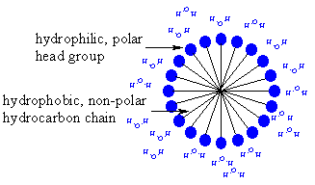(1)
Also may sketch soap ion showing hydrophylic/hydrophobic bits and refer to this in the exp
1 mark

The soap ion has a long hydrocarbon section which is said to be hydrophobic. This part of the soap ion is non-polar and as such not attracted to polar solutes but is attracted to non polar solutes. (1)
1 mark

The head or ionic part of the soap ion ( COO⁻) is said to be hydrophobic. This part of the soap ion is charged and as such not attracted to non polar solutes but is attracted to polar solutes. (1)
1 mark

When soap is added to water, hydrophobic non-polar end of the soap molecule links to the polar impurity like oil and the hydrophylic or polar end links to the water molecule (1).
1 mark

Question 30 [9 marks]
Complete the table below by giving a brief description of a chemical test that could be used to distinguish between the substances listed. List the observations relating to the test for each of the substances.

Substances to  be distinguished | Description of chemical test | Observation with  Substance 1 | Observation with Substance 2
Substance 1  pentane  Substance 2  2-methyl-2-propanol | Add a carboxylic acid, such as acetic acid, that also contains  1 mark  contains a few mLs of  of 2M H₂SO₄,the mixture can also be warmed in a water bath. | No observable change.  1 mark | A fruity odour can be detected  1 mark
Substance 1  potassium sulfate solution  Substance 2  sodium hydroxide solution | Add a few drops of barium nitrate solution, any soluble barium compound will do.  Alternatively any soluble Mg²⁺ ,Cr³⁺, Mn²⁺, Fe²⁺, Fe³⁺, Co²⁺, Cu²⁺, Ni²⁺, Zn²⁺, Cd²⁺, Al³⁺, Sn²⁺ etc (1)  1 mark | The mixture goes cloudy white as a Ba precipitate forms.  Other cations give different observations. (1)  1 mark | The mixture remains colourless and clear (ie no change).  Other cations may give different observations.  1 mark
Substance 1  propanone  Substance 2  propan-2-ol | Add some acidified potassium permanganate (or dichromate).  1 mark  (½ mark -if the student  doesn’t specify that the soln is acidified.) | Upon addition of the acidified potassium permanganate the mixture turns purple and remains purple. (1)  1 mark | Upon addition of the acidified potassium permanganate the mixture turns purple but then goes colourless or peachy  1 mark

Question 31 [5 marks]
- Write the electronic configuration of a sodium atom and a magnesium atom.
1 mark
½ mark each
Sodium 2, 8, 1 Magnesium 2, 8, 2

The first five ionisation energies of sodium and magnesium in MJ mol⁻¹ are shown below:
Ionisation | 1st | 2nd | 3rd | 4th | 5th
Sodium | 0.502 | 4.569 | 6.919 | 9.550 | 13.356
Magnesium | 0.744 | 1.457 | 7.739 | 10.547 | 13.636

- Account for the difference in the 1st ionisation energies of sodium and magnesium? (2 marks)
1 mark
The magnesium nucleus has a greater nuclear charge (12⁺ instead of 11⁺) and so the outer electrons are attracted more strongly and so a greater ionisation energy is required to remove the first electron.
1 mark

- Account for the difference in the 2nd ionisation energies of sodium and magnesium? (2 marks)
1 mark
The second electron for Na is in a lower numbered shell, 2nd shell, than Mg, 3rd shell. As the second shell is on average much closer to the nucleus than the third shell then the second electron for Na is attracted much more strongly than is the second electron for Mg. This results in the higher 2nd IE for Na.
1 mark

Question 32 [4 marks]
Draw complete structural formula for the substances being described.

- an alpha amino acid with four carbon atoms (1 mark)
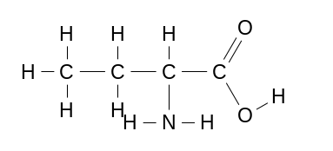
1 mark
- the compound propyl ethanoate (1 mark)
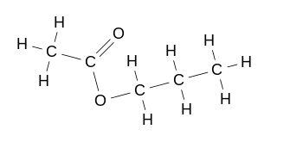
1 mark
- the cis isomer of C₃H₅F (1 mark)
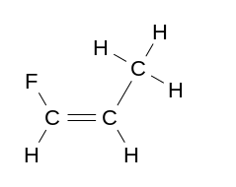
1 mark
- the compound 2- hydroxyhexanoic acid
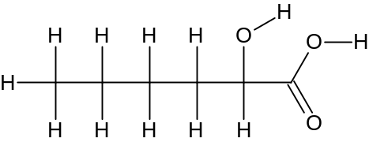1 mark

Question 33 [11 marks]
Complete the following table showing the electron dot diagram, shape, molecular polarity and name the shape for the three species listed.
Cl₂CO | F₂CH₂ | SO₄²⁻
Electron dot diagram (1)  1 mark  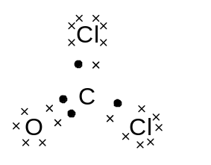 | Electron dot diagram (1)  1 mark  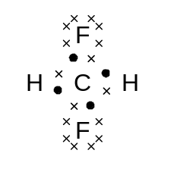 | Electron dot diagram (1)  1 mark  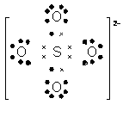
Sketch shape  1 mark  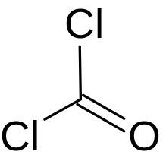 | Sketch shape (1)  F  H  H  Cl  F  1 mark | Sketch shape (1)  O  O  O  S  O  1 mark
Name shape Trianglar Planar  1 mark | Name shape Tetrahedral  1 mark | Name shape Tetrahedral  1 mark
Polarity Polar (1)  1 mark | Polarity Polar (1)  1 mark

Question 34 [7 marks]
- Give the IUPAC name for the following compounds and rank them according to their boiling point. In the table write “1” for the compound with the highest boiling point, down to “4” for the compound with the lowest boiling point. (4 marks)
1 mark
Compound | Molar mass  g mol⁻¹ | IUPAC name  2 marks  (2 marks) | Boiling points (1=highest, 4=lowest)  (2 marks;  2 marks allow -1 ea error  -1 each error)
CH₃CH₂COOH | 74.1 | propanoic acid (1/2 mark) | 1
CH₃CH₂CH(CH₃)₂ | 72.1 | methylbutane (1/2 mark) | 4
CH₃CHOHCH₂CH₃ | 74.1 | butan-2-ol (1/2 mark) | 2
CH₃COCH₂CH₃ | 72.1 | Butanone (1/2 mark) | 3

- How would the boiling point of the compound propan-2-amine compare with that of CH₃CH₂CH₃. Support your answer with reference to intermolecular forces. (3 marks)

The structure of propan-2-amine is
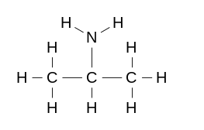
The structure of CH₃CH₂CH₃ is
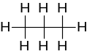
.The hydrocarbon propane has dispersion forces only
1 mark
1 mark
The amine group is site for H bonding,
1 mark
therefore the propan-2-amine would have the higher boiling as its intermolecular are stronger

Question 35 [6 marks]
The atomic radii of some of the elements in groups 1-17 of the Periodic Table are shown in the
table below. The values are given in nanometres (nm), some radii have been omitted.

Group | 1 | 2 | 13 | 14 | 15 | 16 | 17
Period 2 element | Li | Be | B | C | N | O | F
atomic radius in nm | 0.134 | 0.125 | 0.090 | 0.077 | 0.075 | 0.073
Period 3 element | Na | Mg | Al | Si | P | S | Cl
atomic radius in nm

- (i) Describe the trend shown in atomic radius across period 2. (1 mark)
1 mark
Decreases Left to Right_(1)

(ii) Account for this trend in terms of atomic structure. (3 marks)
1 mark
protons added to nucleus/nuclear charge increases (1)
electrons added to same shell (1)
1 mark
attraction is greater (1)
1 mark

- Mendeleev studied periodic data to make predictions for the properties of elements which had yet to be discovered. Using your knowledge of periodic trends and the data above, estimate values for the atomic radius of: (2 marks)
1 mark
(i) F 0.070 < radius < 0.073 nm (1) (ii) S radius > 0.073 nm (1)
1 mark
allocate ½ to units ie nm

Question 36 [6 marks]
A variety of organic compounds, labeled A to F are shown here. Use these compounds to answer the following.
A
C
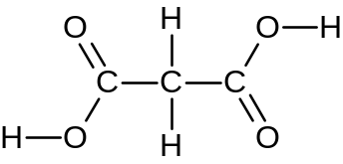 CH₃CH₂CHCH₂ 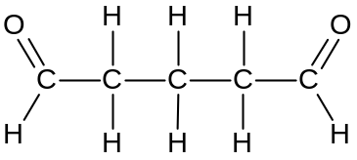
B

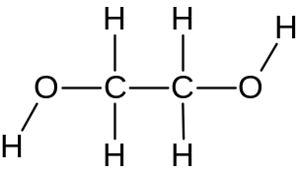 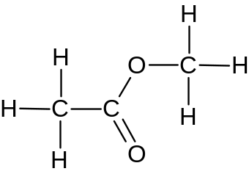 CH₃CH₂Cl
F
D
E

- Using any of the above molecules as monomer(s) draw a structural diagram for a section of a condensation polymer molecule. Your diagram should have two complete repeating units. State the molecule(s) chosen as monomer(s), ie A, B, C, D, E or F. (3 marks)
2 marks
Use monomers A and D (1) Correct diagram (2)
1 mark

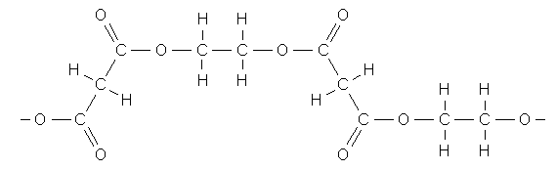

- Using any of the above molecules as monomer(s) draw a structural diagram for a section of an addition polymer molecule. Your diagram should have three complete repeating units. State the molecule(s) chosen as monomer(s), ie A, B, C, D, E or F. (3 marks)
2 marks
2 marks
Use monomer B (1) Correct diagram (2)
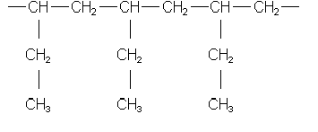

Section Three: Extended answer 40% (80 Marks)
DO NOT WRITE IN THIS AREA AS IT WILL BE CUT OFF

This section contains seven (7) questions. You must answer all questions. Write your answers in the spaces provided.

Where questions require an explanation and/or description, marks are awarded for the relevant chemical content and also for coherence and clarity of expression.

Final answers to calculations should be expressed to three (3) significant figures and include appropriate units.

Spare pages are included at the end of this booklet. They can be used for planning your responses and/or as additional space if required to continue an answer.
- Planning: If you use the spare pages for planning, indicate this clearly at the top of the page.
- Continuing an answer: If you need to use the space to continue an answer, indicate in the original answer space where the answer is continued, i.e. give the page number. Fill in the number of the question(s) that you are continuing to answer at the top of the page.

Question 37 [11 marks]
Esters are the basis of many naturally occurring odours and are therefore widely used in the creation of artificial flavours. The particular ester shown below is a major component that contributes to the smell of pineapple. A manufacturer wishes to produce this compound as a food additive. The reaction involved is shown:

CH₃OH(aq) + C₃H₇COOH(aq) ⇄ C₃H₇COOCH₃(aq) + H₂O(l)
“pineapple” ester

In a trial procedure to produce this ester a chemist uses 3.40 kg sample of methanol with excess butanoic acid. The methanol used is only 88.5% pure as it contains water which is extremely soluble in methanol and is difficult to remove.
1 mark
(a) Name the “pineapple" ester. methyl butanoate (1 mark)

(b) Explain with the aid of a diagram why water is extremely soluble in methanol. (2 marks)

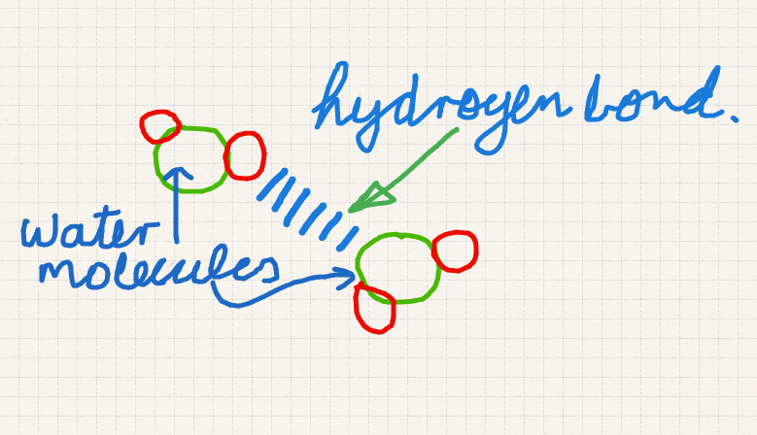 or diagram showing HB between water and methanol
1 mark

Both water and methanol interact by hydrogen bonding. This leads to strong IMF's between water and ethanol. This makes the two substances very miscible in one another and difficult to seperate.
1 mark

(c) What maximum mass of ester can the chemist expect? (4 marks)
DO NOT WRITE IN THIS AREA AS IT WILL BE CUT OFF

1 mark
m(CH₃OH) = 3.40 x 10³ x 0.885 = 3.009 x 10³ g

[M(CH₃OH) = 12.01+4.032+16.00=32.04 g]

1 mark
n(CH₃OH) = 3.009 x 10³ /32.042 = 93.91 mol
1 mark
n(ester) = 93.91 mol

m(ester)_{Exp} = 93.91 x 102.13 = 9591 g = 9.59 kg
1 mark

(d) On completion of the procedure and extraction of the ester the chemist found the process had a yield of 68.5%. What mass of ester was actually produced? (2 marks)

m(ester)_{Actual} = 9591 x 68.5/100 = 6.57 x 10³ g
2 marks

(e) What does the yield of this reaction suggest about the equilibrium constant for the reaction? (2 marks)

The equilibrium constant is greater than 1 (or very close to 1) as the 68.5% yield suggests that products are favoured at equilibrium.
2 marks
Question 38 [14 marks]
The fuel methanol can be manufactured using an equilibrium reaction that is exothermic and involving 91 kJ per mole of CH₃OH produced. The reaction is operated by passing a mixture of hydrogen gas and carbon monoxide gas over a mixture of copper, zinc oxide, and alumina. The process is operated at a pressure of 50-100 atm and a temperature of 250 °C.
DO NOT WRITE IN THIS AREA AS IT WILL BE CUT OFF

(a) (i) Use all of this information to write a balanced chemical equation for the manufacture of CH₃OH. (2 marks)

CO(g) + 2H₂(g)  CH₃OH(g) + 91 kJ correct reactants and products, balanced, heat or ΔH indicated, double arrow used
[deduct 1/2 mark for each omission]
(ii) What is the purpose of the mixture of copper, zinc oxide, and alumina? (1 marks)
1 mark
Acts as a catalyst increasing the reaction rate.
(b) Conducting the synthesis of methanol at a high pressure has several advantages, state two advantages of producing methanol this way and use your knowledge of chemical principles to support your answer. (6 marks)
1 mark
Advantage 1: Reaction rate increased
Explanation based on chemical principles:
1 mark
Increasing the pressure of reactants increases the rate of collisions between reacting molecules. According to the collision theory this increases the rate of reaction.
1 mark
Advantage 2: Yield of Methanol is increased
1 mark
Explanation based on chemical principles:
There is one mole of gas on the product side of the equilibrium and two moles of gas on the reactant side. According to LCP having a higher pressure will favour the side of the equilibrium with fewer moles of gas ie in this case the product. This happens as fewer moles of gas results in a lower pressure counteracting the imposed higher pressure put on the equilibrium system.
1 mark
1 mark

(c) Based on chemical principles alone, pressures well above 300 atm would be even more advantageous. Suggest why such higher pressures are not used. (1 mark)
DO NOT WRITE IN THIS AREA AS IT WILL BE CUT OFF

It becomes uneconomic to use excessively high pressures.
1 mark
(d) The chosen temperature of 250◦C may be something of a compromise. Explain what this means. (4 marks)

Higher temperatures do increase rate as more molecules have enough energy to overcome activation energy. However as the reaction is exothermic then by LCP higher temperatures will favour the reactants thus reducing the yield. This happens as the reverse reaction is endothermic and thus partially counteracts the elevated temperatures. (LCP). Thus temperature needs to be high enough to have a satisfactory rate but low enough to have an acceptable yield.
1 mark
1 mark
1 mark
1 mark

Question 39 [11 marks]
A student carried out an experiment with some magnesium and a hydrochloric acid solution. In this experiment, the student added a granule of barium with a mass of 0.859 g to a conical flask containing 85.5 mL of 0.0951 mol L⁻¹ hydrochloric acid. This resulted in the formation of hydrogen gas as shown here.
Ba(s) + 2HCl(aq) → BaCl₂(aq) + H₂(g)
(a) What was the pH of the solution in the flask prior to adding the barium granule? (2 marks)
1 mark
c(H⁺) = c(HCl) = 0.0951 mol L⁻¹
1 mark
pH = -log [H⁺] = - log 0.0951 = 1.02

(b) Determine the number of moles of barium and hydrochloric acid initially present in the flask. (2 marks)
DO NOT WRITE IN THIS AREA AS IT WILL BE CUT OFF

m(Ba) = 0.859 g
1 mark
n(Ba) = 0.859/137.3 = 6.256 x 10⁻³ mol
1 mark
and n(HCl) = cV = 0.0951 x 0.0855 = 8.131 x 10⁻³ mol

SR = HCl/Ba = 2/1 AR = HCl/Ba = 8.131 x 10⁻³ mol / 6.256 x 10⁻³ mol = 1.29 /1

HCl is the LR

(c) How many moles of hydrogen gas could be expected from this experiment? (2 marks)

HCl is the LR thus

n(H₂) = ½ x n(HCl) = ½ x 8.131 x 10⁻³ mol = 4.07 x 10⁻³ mol
1 mark
1 mark

(d) Calculate the volume of H₂ gas that would be expected if the gas were collected at 28.0 ºC and 104 kPa. (2 mark)

PV = nRT thus V(H₂) = nRT/P = 4.07 x 10⁻³ x 8.3145 x 301/104 = 9.79 x 10⁻² L
1 mark
1 mark

(e) The student repeated this experiment using a granule of calcium of similar dimensions to the granule of barium.

(i) What difference would you expect in reaction rate? (1 mark)

slower reaction rate 1 mark

(ii) Explain your answer to (i). (2 marks)
1 mark
The reactivity of group 2 elements increases down the group thus for the same general reaction Ca is less reactive than Ba.
1 mark
OR

This reaction involves the loss of electrons from Ba/Ca. As ionisation energy decreases down group 2 then Ba loses electrons more easily and would be expected to be more reactive with HCl. (Similary may compare Eº as a guide to tendancy to be oxidised.)
DO NOT WRITE IN THIS AREA AS IT WILL BE CUT OFF
Question 40 [13 marks]
Wines often contain a small amount of sulfur dioxide that is added as a preservative. The amount of sulfur dioxide added needs to be carefully calculated; too little and the wine goes bad; too much and the wine tastes of sulfur dioxide.

The sulfur dioxide content of a wine can be tested by titration with an aqueous iodine solution, I₂(aq). The reaction involved is shown here:

SO₂(aq) + I₂(aq) + 2H₂O(l) → SO₄²⁻(aq) + 2I⁻(aq) + 4H⁺(aq)

(a) What species is oxidised in this reaction? Support your answer with an explanation. (2 marks)
1 mark
Species that has been oxidised SO₂
Explanation: The oxidation number for S in SO₂ is +4 and in the product SO₄²⁻ is +6. As the ON increases so S (or SO₂) is oxidised.
1 mark

(b) Suggest how the end point of this titration might be observed. You may assume the wine is almost colourless and that the iodine solution is added from the burette. (2 marks)

The colourless wine will be in the conical flask and the brown I₂(aq) in the burette. The end point will be indicated when the contents of the flask becomes permanently pale brown (or purple).
2 marks

(c) What problem would you encounter by having the I₂ (aq) solution in the burette? (2 marks)

As the I₂(aq) is a deep brown colour it will be difficult to read the burette level from the bottom of the meniscus. So it may be better to read from the top of the meniscus.
2 marks

(d) The sulfur dioxide content of a white wine sample was found by titration with iodine. In this procedure a laboratory technician measured 50.0 mL of white wine and diluted this to
250.0 mL. She then titrated 20.0 mL samples of the diluted wine with 0.00215 mol L⁻¹ aqueous iodine, I₂(aq). On average 16.40 mL of iodine solution was needed for equivalence. Determine the concentration of sulfur dioxide in the original wine sample in mol L⁻¹. (4 marks)
DO NOT WRITE IN THIS AREA AS IT WILL BE CUT OFF

½ mark
n(I₂) = cV = 0.00215 x 16.4 x 10⁻³ = 3.526 x 10⁻⁵ mol

n(SO₂) = n(I₂) = 3.526 x 10⁻⁵ mol
½ mark
1 mark
c(SO₂) = n/V = 3.526 x 10⁻⁵ /0.0200 = 0.001763 mol L⁻¹l

thus
c(SO₂) in wine = 0.001763 x 250/50.0 = 8.82 x 10⁻³ mol L⁻¹
2 marks

(e) The generally accepted maximum concentration of sulfur dioxide in wine is 0.25 g L⁻¹. Higher concentrations will make the wine taste unpleasant and concentrations less than 0.01 g L⁻¹ are insufficient to preserve the wine. Comment on the effectiveness of the sulfur dioxide in the wine analysed in (d). (3 marks)

c(SO₂) in wine = 8.82 x 10⁻³ mol L⁻¹
2 marks
Thus c(SO₂) in wine as g L⁻¹= 8.82 x 10⁻³ x 64.06 = 0.565 g L⁻¹ mol L⁻¹

1 mark
The SO₂ concentration is too high, ie the wine will taste unpleasant.

Question 41 [9 marks]
Dioxin is a dangerous pollutant that needs to be closely monitored in our food and the environment. The formula of dioxin is C₁₂H₄O₂Cl₄. On combustion, the chlorine in dioxin is completely converted into hydrogen chloride gas. An impure sample of dioxin with a mass of 3.600g was burnt in oxygen. The hydrogen chloride produced was bubbled through 50.00 mL of 1.030 mol L⁻¹ potassium hydroxide solution. The resulting solution was titrated with a standard solution of 0.500 mol L⁻¹ sulfuric acid. End point was achieved using 23.65 mL of the sulfuric acid solution. Calculate the percentage, by mass, of dioxin in the impure sample.
DO NOT WRITE IN THIS AREA AS IT WILL BE CUT OFF

2KOH(aq) + H₂SO₄(aq) ⇄ K₂SO₄(aq) + H₂O(l)

1 mark
n(H₂SO₄) = cV = 0.500 x 0.02365 = 0.011825 mol

1 mark
n(KOH) left = 2 x n(H₂SO₄) = 0.011825 x2 = 0.02365 mol

n(KOH) initially present = cV = 1.030 x .0500= 0.05150 mol
1 mark
n(KOH) used = initial - remaining = 0.05150 - 0.02365 = 0.02785 mol

1 mark
KOH(aq) + HCl(aq) ⇄ KCl(aq) + H₂O(l)
1 mark
n(KOH) = n(HCl) = 0.02785 mol
1 mark
n(Cl) = n(HCl) = 0.02785 mol

n(dioxin) = 0.02785/4 = 0.006963 mol
1 mark

1 mark
m(dioxin) = n x M = 0.006963 x 321.95 = 2.424 g

%(dioxin) = m(dioxine) x 100/m(sample) 2.242 x 100/3.600 = 62.3 %
1 mark

52.9 % = 7 marks

Question 42 [13 marks]
DO NOT WRITE IN THIS AREA AS IT WILL BE CUT OFF
The corrosion of iron is a redox process that causes iron and steel structures to decay and become degraded over time. In an investigation into the corrosion process a student placed some iron nails into a variety of different environments and observed the extent of corrosion that occurred. He compared the extent of corrosion by looking for the amount of orange/brown deposit that formed in the test tubes.
iron nail

tap water
iron nail

salty water
iron nail wrapped in zinc strip

tap water

rank
2
rank
1
rank
3
2 marks must be completely correct

- What is the likely chemical composition of the orange/brown precipitate? (2 marks)
2 marks
Fe(OH)₃ or hydrated Fe(III) oxide

- Rank the three tubes 1 (the most corrosion) to 3 (the least corrosion). Place your ranking in the boxes above. (2 marks)

- Explain how the zinc strip and iron nail used above could be arranged to make an electrochemical cell that would produce an electric current. You can use any of the glassware usually available in a school laboratory. If you are using any other reagents to produce your cell you should note this. Include a labeled diagram of your electrochemical cell and give a detailed description of how it operates. (9 marks)

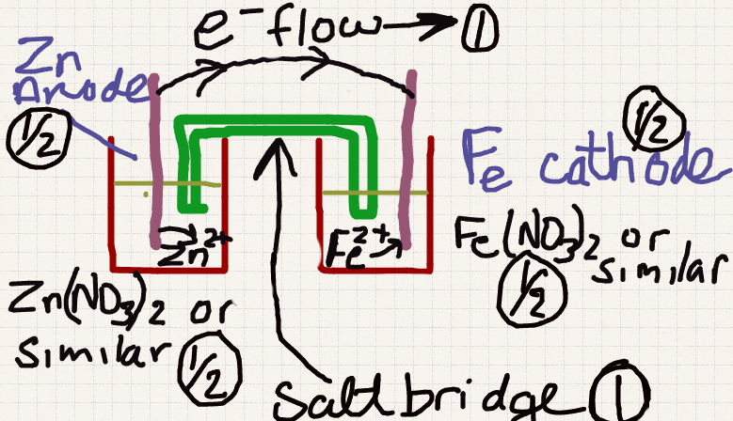
4 marks for good fully labelled diagram
DO NOT WRITE IN THIS AREA AS IT WILL BE CUT OFF
Relevant reactions Zn(s) → Zn²⁺(aq) + 2e⁻ Eo = 0.76................. ...①
Fe(s) → Fe²⁺(aq) + 2e⁻ Eo = 0.44.................. .②
Overall Zn(aq) + Fe²⁺(aq) → Fe(aq) + Zn²⁺(aq) Eº = 0.32. ③

As the cell operates the more reactive Zn electrode dissolves as it becomes oxidised forming Zn²⁺ ions. (See reaction ② above) The zinc forms the anode of the cell and electrons leave the Zn electrode via the external conducting wire towards the iron electrode. At the Fe electrode cations from the solution, ie Fe²⁺ ions migrate towards the iron electrode, the cathode and become reduced to Fe. (See reaction ①above)

The overall redox reaction has a positive potential of 0.32 Volts. (See reaction ③above)

Within the cell cations build up in the reduction half cell and these migrate through the salt bridge and towards the iron half cell. Anions travel in the opposite direction.
5 marks for a description of how the cell operates.

Look for a coherent answer with no errors and most of the above points for full marks. Remember some points like anode, cathode, electron flow, ion flow have already been allocated marks in the diagram section of the cell.

Reduce the mark as errors increase or omissions increase.

Question 43 [9 marks]
DO NOT WRITE IN THIS AREA AS IT WILL BE CUT OFF
A 3.210 g sample of an organic compound containing the elements carbon, hydrogen and chlorine only is burnt in air. All of the water produced during the compounds combustion was absorbed by bubbling the gas mixture of combustion products through some pure sulfuric acid. The resulting sulfuric acid mixture increases in mass by 0.6446 g.

- What is the mass of hydrogen in the sample of organic compound? (1 marks)

m(H₂O) = 0.6446 g ; n(H₂O) = m/M = 0.6446/ 18.016 = 0.03578 mol

n(H₂) = 2/1 = 2 x 0.03578 = 0.07156 mol
½ mark

m(H₂) = 0.07156 x 1.008 = 0.0721
½ mark

The remaining products of combustion are then passed through a sodium hydroxide solution, thus absorbing any carbon dioxide present as sodium carbonate. Addition of excess calcium nitrate solution yields a precipitate of calcium carbonate. When washed and dried the resulting calcium carbonate was found to have a mass of 4.810 g.

- Determine the mass of carbon in the sample of organic compound. (2 marks)

m(CaCO₃) = 4.810 g

n(CaCO₃) = m/M = 810 / 100.09 = 0.04806 mol
½ mark

n(C) = 0.04806 mol
½ mark

m(C) = 0.04806 x 12.01 = 0.577
1 mark

- Determine the organic compound's empirical formula. (4 marks)
1 mark
m(Cl) = 3.210 - (m_{c} + m_{H}) = 3.210 - 0.5772 - 0.07213 = 2.561 g

Moles C H Cl

0.5772 0.07213 2.5607
12.01 1.008 35.45
1 mark
0.0480 0.0716 0.0722

Ratio 1 1.5 1.5
1 mark

ie 2 3 3
1 mark
thus EF is C₂H₃Cl₃

- Draw a possible structure for the compound (1 marks)

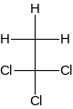 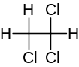 1 mark

- Name the compound (1 marks)

1,1, 2 trichloro ethane or 1,1,1 trichloro ethane 1 mark

END OF PAPER :)

